Software engineering for big data analaysis

CSA-1035

EXP NO: 23

1. Draw a Class diagram for an e-library online public access catalogue. The activities of the system are listed below. Patrons of a library can search the library catalogue online to locate various resources - books, periodicals, audio and visual materials, or other items under the control of the library. Patrons may reserve or renew items, provide feedback, and manage their account.

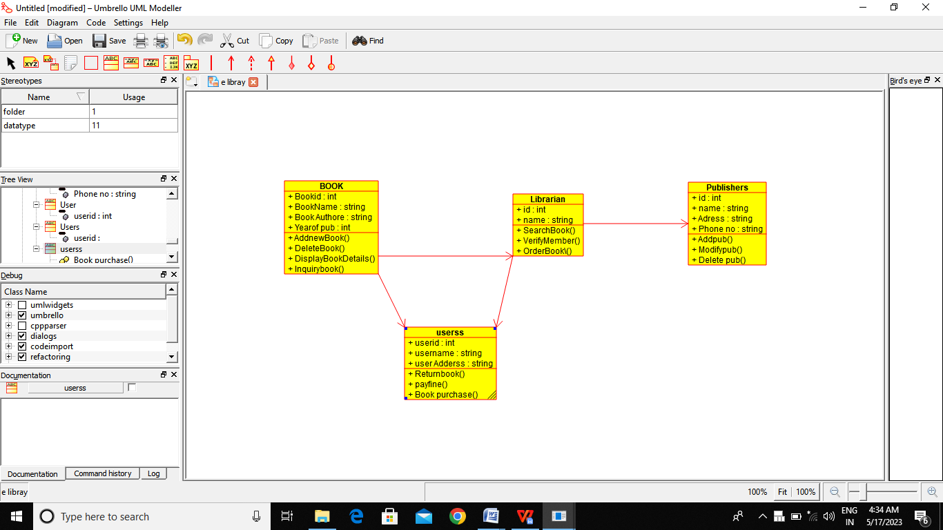

Result:-

Thus the class daigram for e libray is drawn and verified successfully